DAA Lab Assignment – 1

1. Merge Sort
Time Complexity: O(n log n) (best, average, worst)
Space Complexity: O(n)
Stable and reliable but uses more memory.

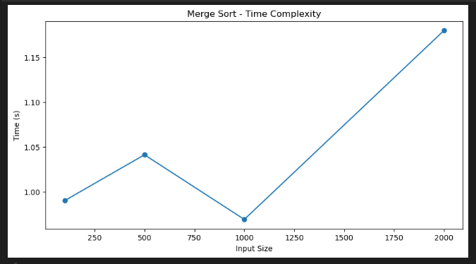
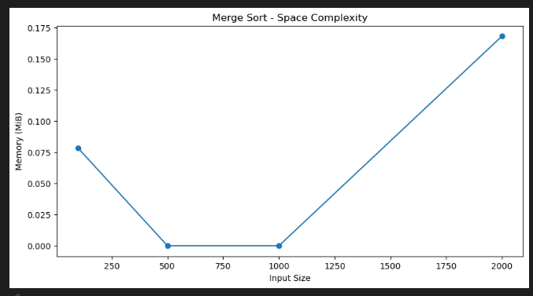
2. Quick Sort
Time Complexity: Best & Average O(n log n), Worst O(n²)
Space Complexity: O(log n)
Very fast in practice but recursive, so risk of stack overflow.

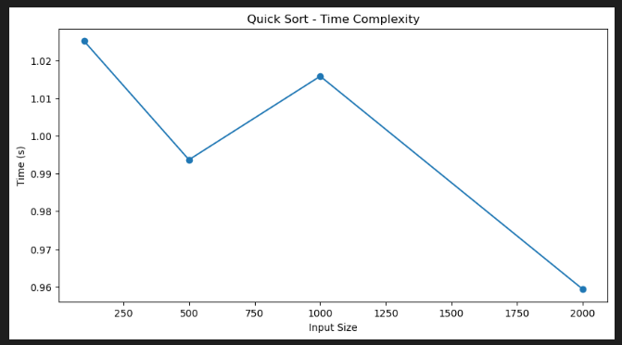

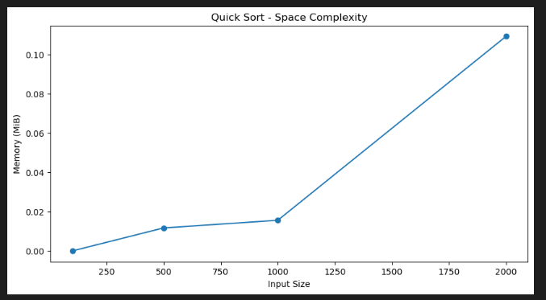
3. Insertion Sort
Time Complexity: Best O(n), Worst O(n²)
Space Complexity: O(1)
Works well for small or nearly sorted data.

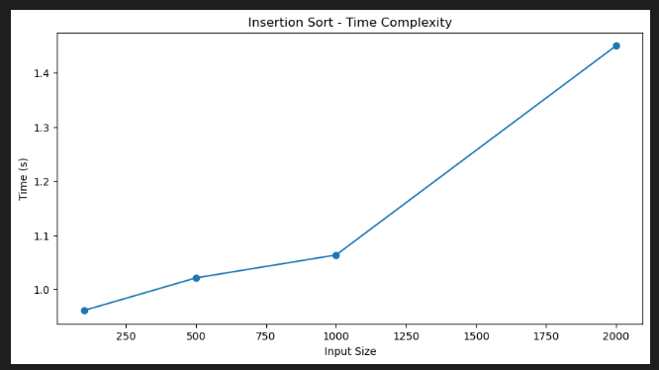

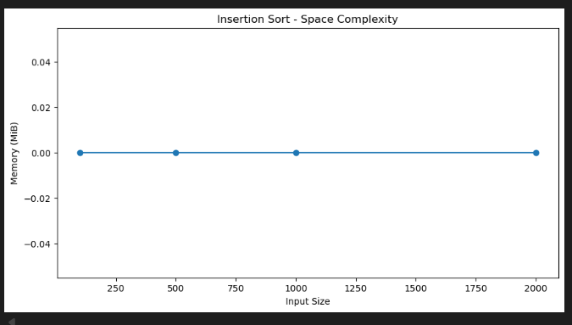

4. Bubble Sort
Time Complexity: O(n²)
Space Complexity: O(1)
Simple but very slow.

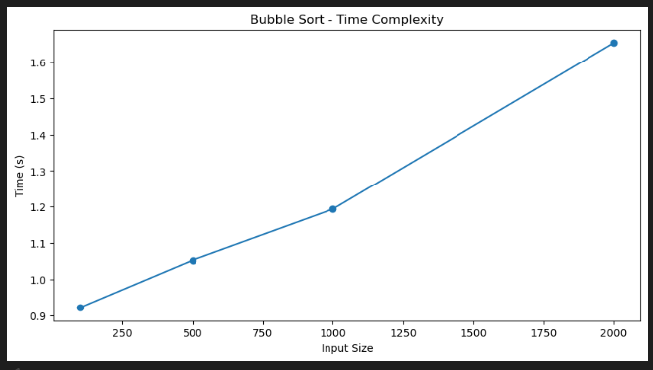

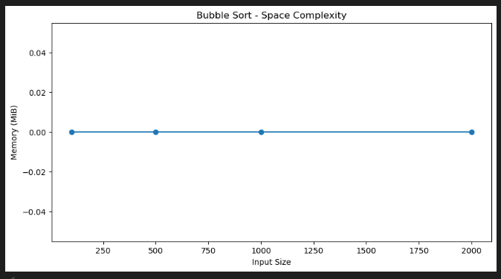
5. Selection Sort
Time Complexity: O(n²)
Space Complexity: O(1)
Simple, not practical for large datasets.

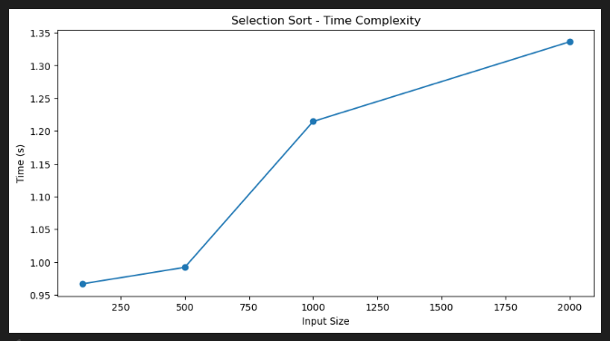

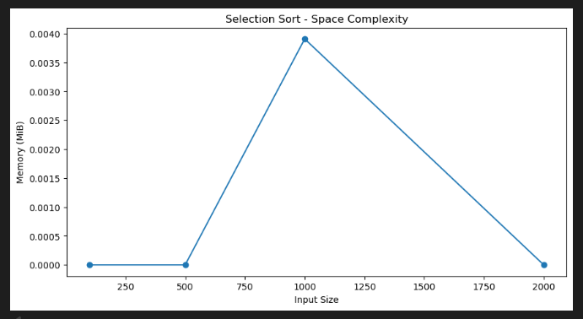

6. Fibonacci (Dynamic Programming)
Input: A number n
Output: nth Fibonacci number
Time Complexity: O(n)
Space Complexity: O(n) (can be optimized to O(1))
Much faster and scalable than recursive.

7. Fibonacci (Recursive)
Input: A number n
Output: nth Fibonacci number
Time Complexity: Exponential O(2^n)
Space Complexity: O(n) (recursion stack)
Suitable only for very small inputs. Risk of stack overflow if n is large.

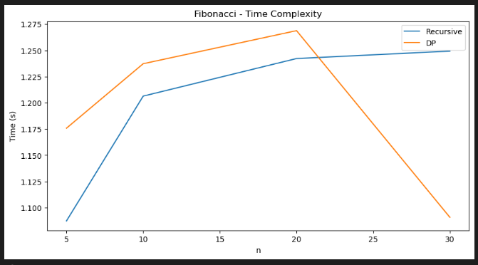

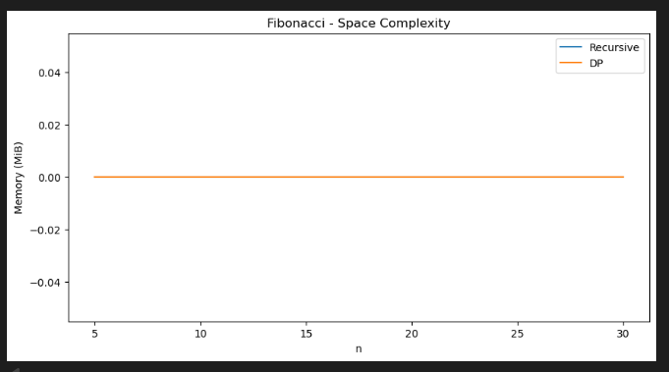

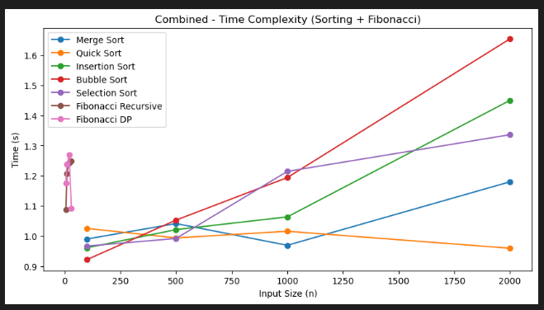

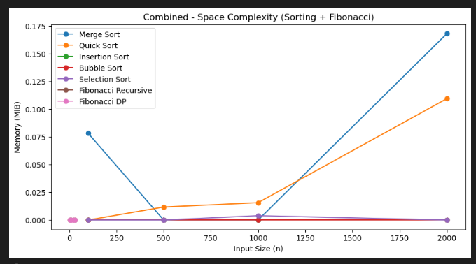

✅ 1. Plot execution time vs. input size using matplotlib
Execution time increases with input size for all algorithms.
Efficient algorithms (Merge Sort, Quick Sort, Fibonacci DP) scale much better compared to inefficient ones (bubble Sort, Selection Sort, Recursive Fibonacci).
Graphs clearly show the difference between O(n log n) vs. O(n²) vs. Exponential O(2ⁿ).

✅ 2. Discuss trade-offs in time vs. space complexity
Some algorithms like Merge Sort use extra memory (O(n)) for merging, but they guarantee O(n log n) time.
Quick Sort is faster in practice and uses less memory, but worst-case time is O(n²) if pivot is bad.
Bubble Sort, Insertion Sort, Selection Sort use very little extra space (O(1)), but are slow (O(n²)).
Fibonacci recursive uses exponential time and large recursion depth, but very little code.
Fibonacci DP uses more memory (array/table), but reduces time to O(n).
👉 Trade-off = Faster algorithms often use more memory, while memory-efficient algorithms may take more time.

✅ 3. Comment on recursive depth and stack overflow risks
Recursive Fibonacci grows recursion depth linearly with n, leading to very deep recursion for large inputs. This can cause stack overflow in Python if n is too large (default recursion limit ≈ 1000).
Merge Sort and Quick Sort also use recursion, but depth is O(log n), which is safe even for large inputs.
Dynamic Programming Fibonacci avoids recursion, so no stack overflow risk.
👉 Recursive depth is a serious concern mainly in naïve recursive algorithms (like Fibonacci).

